**School of Engineering and Applied Science**



**Department of Electrical and Computer Engineering**

**______________________________________________________**

**ECE 570.S: Software GPS Receiver**

**The Kalman Filter**

**Jared Morell**

**Dr. Morton**

**May 6, 2011**

**Introduction and Background**

What is it?: optimal recursive data processing algorithm

Purpose: use measurements observed over time, containing noise, to produce values closer to the true values of the measurements.

Uses: navigation, surveying, vehicle tracking, geology, oceanography, fluid dynamics, steel/paper/power industries, and demographic estimation, to mention just a few [2].

Predicts a value, estimates its uncertainty, computes weighted average of predicted and measured values.

Most weight given to value with least uncertainty. For instance, if the measurement noise covariance is smaller than that of the predicted value, the measurement’s weight will be high and the predicted estimate’s will be low. These weights, just like the predicted state estimate, change with time.

This results in the estimates being closer to the actual values than the predicted or measured values alone

A Kalman filter is used to estimate the states of a system based on its outputs, in order to describe the system as a function of time. A system, however, has noisy outputs. According to Levy, these noisy outputs can be thought of as a multidimensional signal plus noise; and the system states are the desired, unknown signals. The Kalman filter can be used to filter the noisy measurements to best estimate the desired signals.

Why it is optimal:

-Processes all available measurements to estimate the current value of the variables of interest. It uses knowledge of the system and measurement device dynamics, the statistical description of the system noises, measurements errors, and uncertainty in the dynamics models, and any available information about initial conditions of the variables of interest.

- Essentially, it minimizes mean-square estimation errors

-many ways to determine velocity of an aircraft. Rather than choosing one and disregarding the others, a Kalman filter could be built to combine all data and knowledge of various systems’ dynamics to generate the best overall estimate of velocity [3]

-the Kalman filter can be shown to be the best filter of any possible form [3]

practical applications of the Kalman filter require adequate statistical modeling and numerical precision [2]

It is recursive in that it does not need all previous data to be stored in memory and reprocessed with each new measurement. The algorithm repeats itself for each new measurement vector, using only values stored from the previous cycle. This recursive algorithm is illustrated by Levy below, in Figure 1.

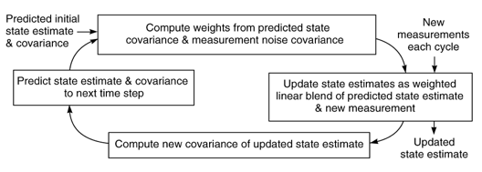

Figure 1: The Kalman filter algorithm is linear and recursive. The predicted state estimate is updated with each cycle by combining new measurements with the state estimate from the previous time sample.

Example application from Wikipedia “Kalman filter”

**The Mathematics of Kalman Filtering**

Blue box in [2]

**The Kalman Filter in Navigation**

It can be seen that the Kalman filter has the potential to benefit countless systems, and navigation is without a doubt one of them. The Kalman filter is used in coordination with both GPS/INS integration and GPS stand-alone systems for improved overall navigation performance [2].

The Kalman filter is a linear algorithm. It also assumes that the systems generating the measurements are also linear. Because GPS and INS are both nonlinear, a linearization of their integration needs to take place [2]. Figure 2 shows how the two systems are used in coordination with one another and the Kalman filter.

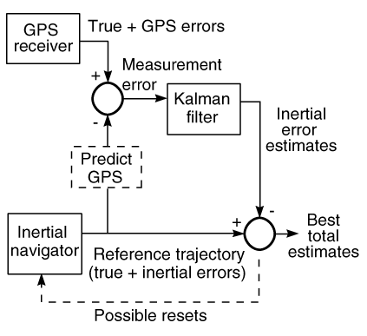

Figure 2: How GPS/INS integrated systems can use a Kalman filter to improve performance

As seen in Figure 2, the true values of both the GPS and INS systems cancel out. As a result, only the systems’ errors need to be modeled. Such errors from GPS could include receiver clock, ionosphere errors, troposphere errors, multipath, and satellite ephemeris and clock errors. INS errors include position, velocity, acceleration, and orientation inaccuracies.

When INS is not available, the Kalman filter is used solely by the GPS receiver. In this case, some receiver equations of motion (such as dead reckoning) are used to replace the inertial system. These simpler equations of motion tend to result in larger errors and less accurate estimates in moving receivers [2].

**Works Cited**

[1] B.L. Malleswari et al. “The Role of Kalman Filter in the Modeling of GPS Errors.” Journal of Theoretical and Applied Information Technology. Vol. 5. No. 15 (2009): 95-101.

[2] Levy, Larry. “The Kalman Filter: Navigation’s Integration Workhorse.” *The Johns Hopkins University Applied Physics Laboratory*. 1998.

[3] Maybeck, Peter. “Chapter 1: Introduction.” *Stochastic Models, Estimation, and Control, Volume 1*. New York: Academic Press, 1979.